**LAPORAN UTS SURAT MASUK**

**MATA KULIAH**

**FRAMEWORK PROGRAMMING**

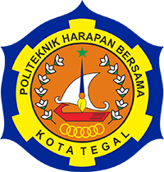

**Oleh :**

**Nitah Pangestuti**

**POLITEKNIK HARAPAN BERSAMA**

**TEGAL**

**2021**

Link github : <https://github.com/NitahPangestuti/uts>

1. Use Case Diagram

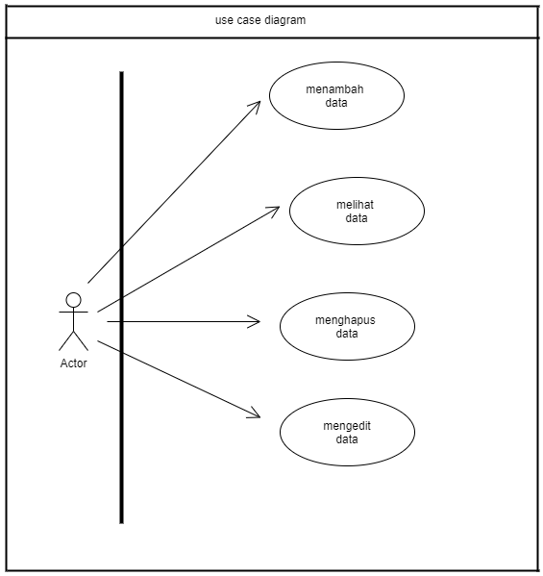

1. ActivityDiagram

Diagram Activity - Tambah Data

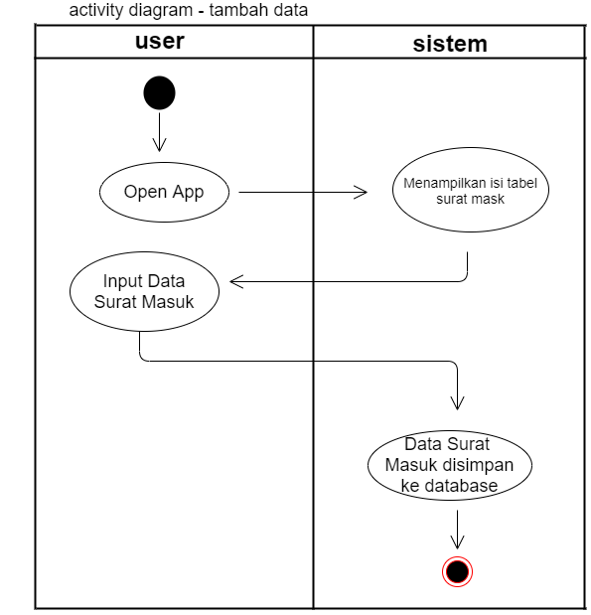

Diagram activity - Hapus Data

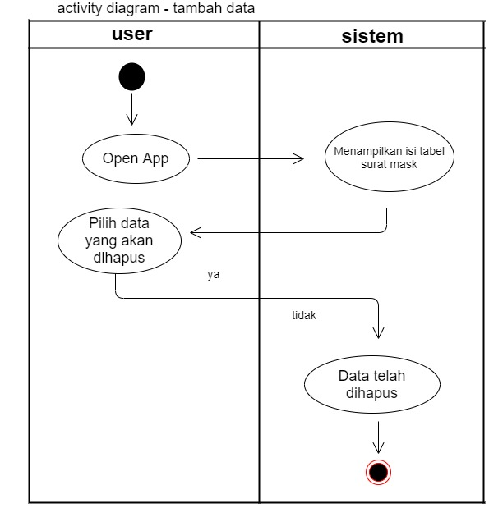

Diagram Activity - Edit Data

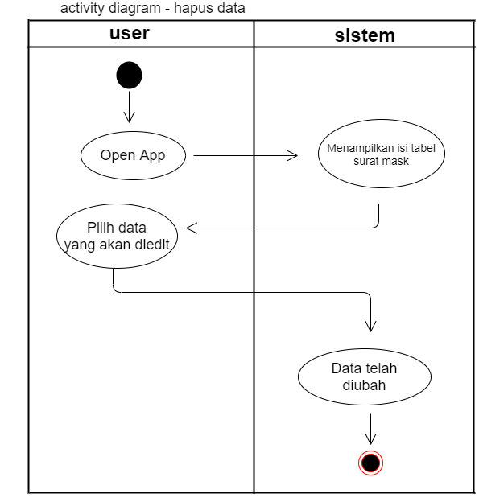

1. Squence Diagram

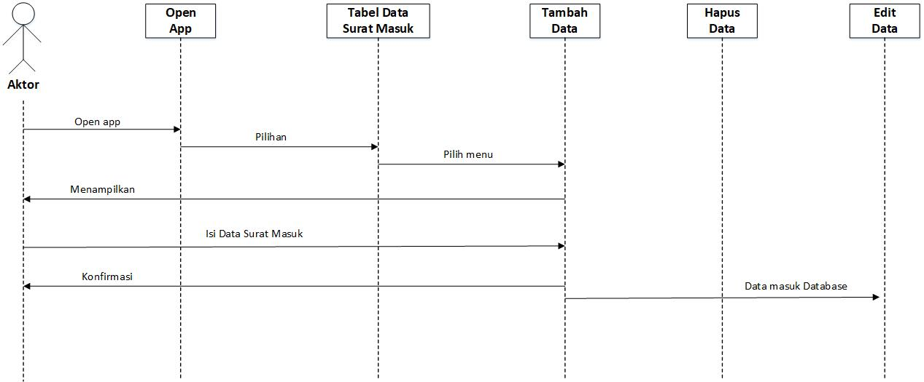

1. Class Diagram

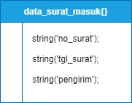

1. Penjelasan Diagram

